|  |  |
| --- | --- |
| Excel Homework - Kickstart My Chart | Eli Payne  10/5/2019 |

1. **Given the provided data, what are three conclusions we can draw about Kickstarter campaigns?**

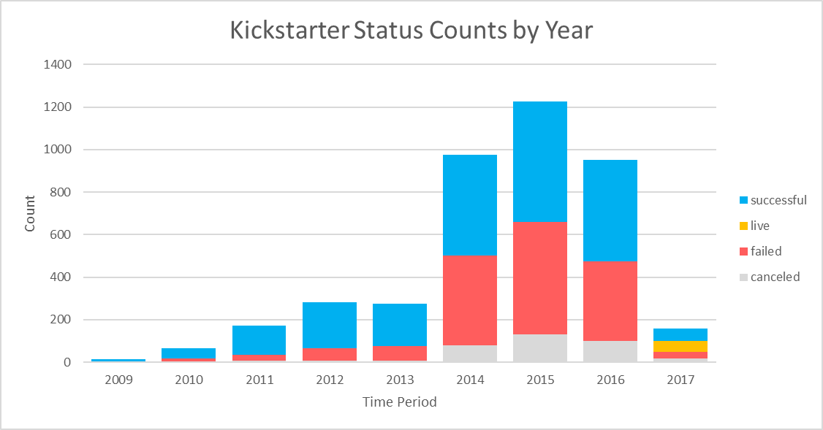

*Figure 1*

The total number of kickstarters grew gradually from inception in 2009 until about 2012, held steady for a couple years, then exploded in popularity in 2014. After peaking in 2015, there appears to be a gradual decline, but there isn’t enough recent data to reach firm conclusions about ongoing volume.

*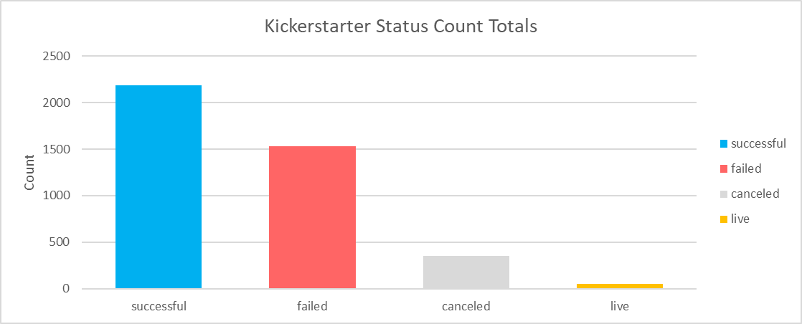Figure 2*

There majority of all kickstarters are successful, but since 2014 the proportion of failures and cancellations has greatly increased (see *Figure 1*).

*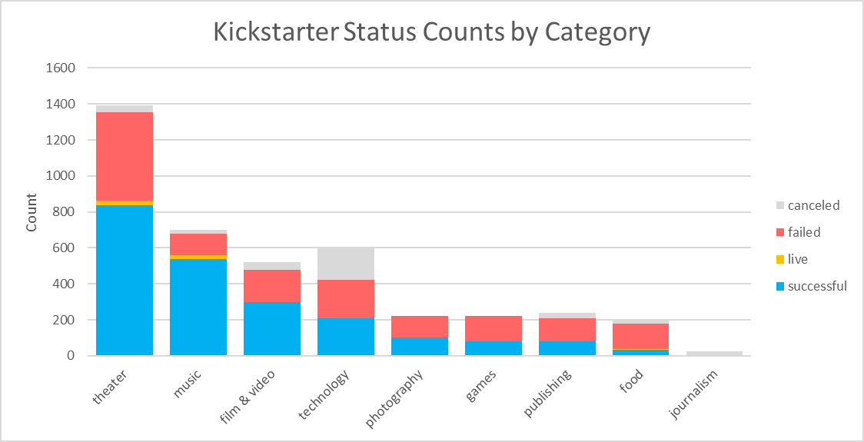Figure 3*

The category with the highest total number of successful Kickstarters is Theater, while the category with the highest proportion of successes is music. Food is the least likely to be successful, unless you include journalism, whose projects, apparently, never make it far enough to be considered failures.

The stories change when the parent categories are split into sub-categories. See figure below:

*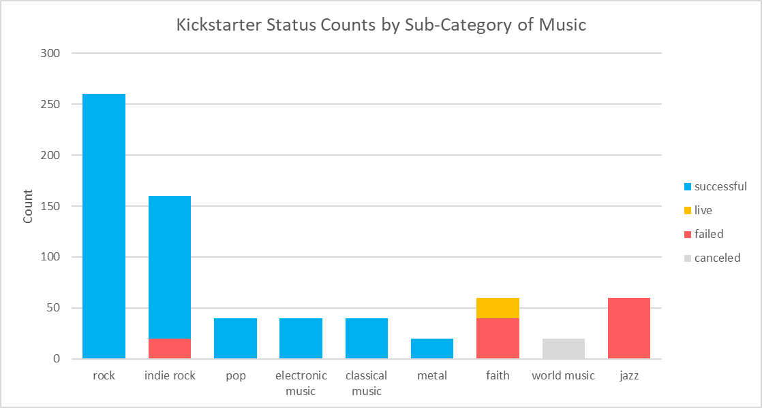Figure 4*

Not every type of music is popular.

1. **What are some limitations of this dataset?**

* Data ends in Q1 2017, no recent data.
* Majority of data comes from English-speaking coutries—United States, followed by Great Britain, Canada, and Australia. Inferences made about other countries will be less robust.
* No granular location data. Kickstarters in certain states, cities, provinces, etc. may be more popular than others.
* No outside popularity information. I don’t know of a clean way to quantify this information, but a lot of individual kickstarters’ successes are based on luck and whichever happen to go viral, or celebrity promotions.

1. **What are some other possible tables and/or graphs that we could create?**

*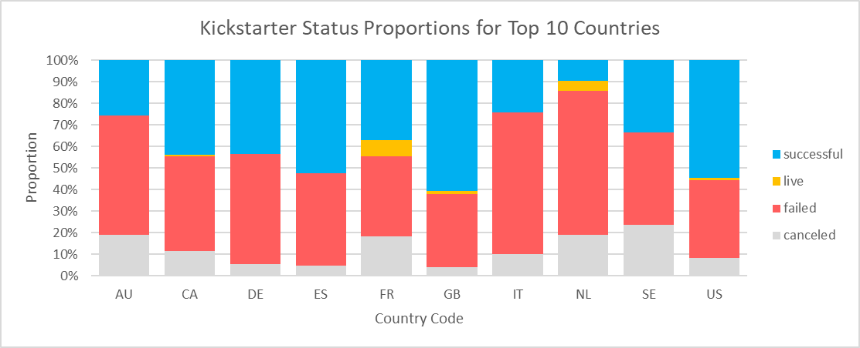Figure 5*

Some countries have higher success proportions than others (with the caveat the English-speaking countries have the most data).

*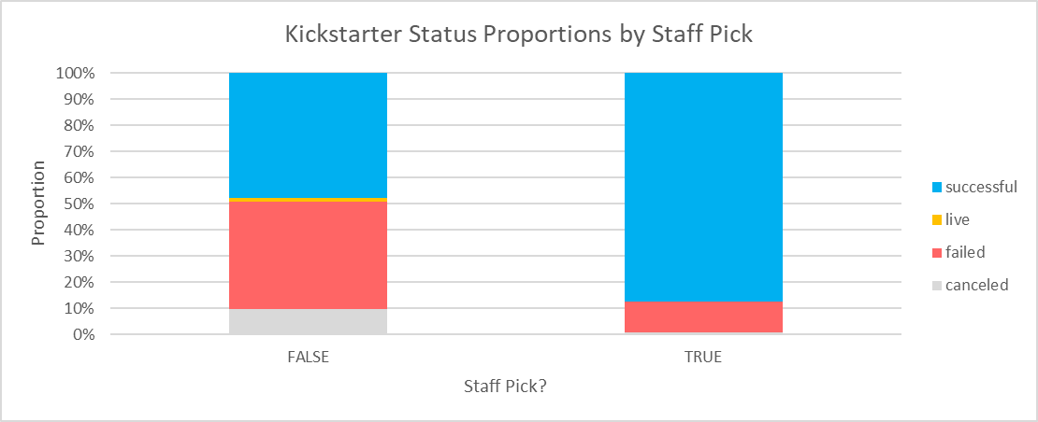Figure 6*

Kickstarters listed as staff picks have a higher proportion of successes, though causality cannot be inferred—we don’t have information about when staff make their picks, so they could, for instance, pick projects that already have some momentum.

**Bonus:**

*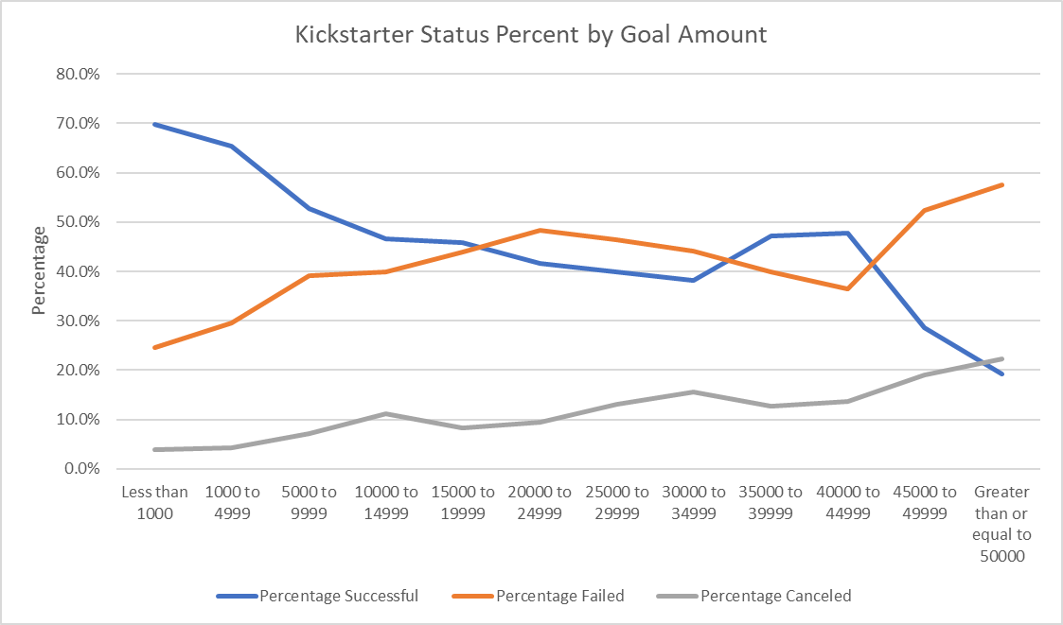Figure 7*

